THE ROLE OF INNOVATIVE SHORT FOOD SUPPLY CHAINS IN ENHANCING THE RELATIONSHIPS BETWEEN THE CONSUMERS AND PRODUCERS: THE CASE OF THE FOOD ASSEMBLY MODEL IN THE CITY OF MADRID.

Ameur Sia*ª; Javier Sanz Cañada^{b}; Tomás Garcia Azcarate^{c}
ªMaster of Science in Agro-food Marketing, Madrid, ameursia1@gmail.com
^{b}Investigador del Instituto de Economía, Geografía y Demografía del CSIC, Madrid, javier.sanz@cchs.csic.es
^{c}Investigador del Instituto de Economía, Geografía y Demografía del CSIC, Madrid, tomasgarciaazcarate@gmail.com

Abstract:

The work highlights the potential of a new initiative that allows the purchase of organic and artisanal food products directly from the local producers called “The Food Assembly” (“La ruche qui dit oui” en francés y “La colmena que dice sí” en España)..

Key words: Short food supply chains, Food Assembly

Introduction, objective and methodology

“The Food assembly” is a model of commercialization of agro-food products born in France in 2010 and rapidly have been spread through the other European countries. The model works with an online platform considered as a tool for logistic management which facilitates the distribution of the products by minimizing the number of intermediaries and connecting all the stakeholders related to this model on a relay point on weekly basis to form a sort of a small community and allowing interaction between them.

The study aims to analyze this newly embarked model in Spain to understand the motivation of the consumers, producers and coordinators to integrate the Food Assemblies and testing 2 hypotheses, whether internet could have a positive impact on the development of short food supply chains (SFSC) and whether “The Food Assembly” could be considered as a sustainable model of SFSC.

An “open basket system” is implemented. The consumers have the freedom each week to buy or not to buy and a wide range and variety of products, without any kind of compromise or commitment. Their motivations are mixed between heath and taste on one hand and social and environmental responsibilities on the other. Producers decide not only what and when the produce but the selling price. The “Food assembly fee” is very limited, only 16.70%, half for the coordinator and half for the central house.
To achieve our objectives, a random survey has been done for the consumers, at the entrance door of their hike, and semi directive interviews were designed for producers and coordinators. Four components have been addressed: motivation, functioning, interpersonal relationships and satisfaction. They were specifically targeted for each of the three different stakeholders. The total sample of the study consisted of 51 consumers, 14 producers and all the 11 hives’ coordinators in city of Madrid in February 2017.

Results

We are now presenting some of our more interesting results. As a general conclusion, we can conclude that our results are leading to confirm the initial drawn hypothesis. It is a useful tool highly appreciated by consumers, producers and coordinators.

Consumers

Through “The food Assembly”, the consumers have a direct contact with the producer sand are informed about the production process and the origin of the food. Obviously, they have access to healthy products marked by high quality. This is why 61% of them have declared their willingness to increase their purchase in the near future, 39% to maintain and no one have an intention to reduce them. The most important critic they made to the system is the limited (some hours a week) window they had to collect the products.

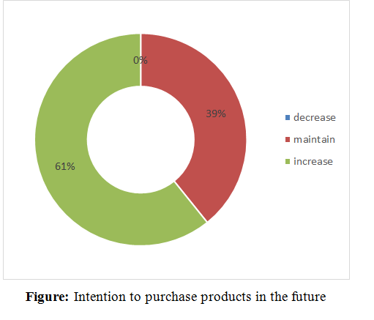

The consumers were asked to declare the average amount of money they spend weekly on buying products through “The Food assembly”. The results indicate that 49% spend between 20-40 Euros, 41.2% spend more than 40 Euros and only 9.8% spend less than 20 Euros. At least in the city of Madrid, they have a more or less homogenous profile where the majority of them is belonging to groups of middle income with high level of education and very aware about their diet and health.

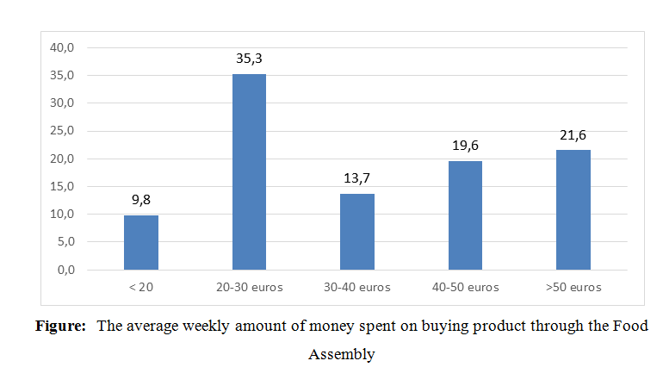
Producers
As far as the producers are concerned, 28% of them are under 35 years old and 72% are between 35 and 55 years old and all of them have a university degree except one who has a secondary level. 50% practice another activity, 46% run their activities with other family members but 35% hire some contracted workers.
On average, the interviewed producers are far from “The Food Assemblies” by 48 kilometers; the distribution of their products till the hives is done by themselves or through collaboration with other producers; each of them is supplying regularly 4 hives each week except when they face some circumstances such as holiday periods or when there is not enough production due to the seasonality.
Coordinators
They play a major role as they are the responsible of establishment of links between the consumers and producers by contacting the producers for the weekly tasting sessions, solving the appeared problems, receiving all the claims and solving them as soon as possible.
The results of the interviews indicated that all the 11 coordinators are women except one hive which is managed by a man, all of the coordinators have another job activity beside the one related to the management of the Food Assemblies. They are working on general during 10 hours per week; 2 hours are dedicated for the distribution day and 8 hours for managing the hive by contacting the producers and animating the online store during the other days.
One of the most active hives that we have interviewed has left “The Food assembly” since then and created its own structure. They argued that the coordinator fee is too low (8.35%) and the central house fee (another 8.35%) too high. This would be why their time investment has to be limited and the window given to consumers for collecting the products has to be limited. Now, they work on their own; they have decrease the global fee to 15%, of which 12% is for the coordinator and 3% is devoted to finance social activities. At the same time, they have multiplied the collecting points, including several schools and a church, and are planning to provide on a regular basis some scholar canteen.

Conclusions

“The Food assembly” model is developing quickly. From February to June 2017, the number of hives has increased from 11 to 39. In our survey, the majority of the coordinators were newly integrated into the Food assembly model: 45% of them had opened their hives in less than six months before, 36% they had already an experience between six months to less than one year and the left more than one year

As compared with other direct sale models, the “Supported Community Agriculture” initiatives require a strong personal commitment from the consumers and not everybody has the available time and energy. In addition, the freedom to choose is limited, if any, and the list of available products is more limited.

The producers are small ones with limited resources for marketing and communication, It has been observed that “The Food Assembly” is fostering and enhancing the marketing side by giving them the possibility to trade via online stores for free. They receive 86 % of the final price paid by the consumers. Therefore, local producers are happy to work with “The Food assembly”. At the same time, the ending price for the consumer is closer to standard products in traditional retailers, cheaper than in the organic shops.

Our 2 hypotheses have been confirmed. On one hand, internet has a positive impact on the development of short food supply chains (SFSC) and contributes significantly to close the gap between consumers´ demand and producers ‘supply. On the other, “The Food Assembly” is an expanding, successful and sustainable model of SFSC.

Our results deserve therefore to be revisited, first, with an enlarge number of interviews, and, second, in some years in order to catch and analyze the quantitative and qualitative evolutions which will continue to happen.

Bibliography
Casal, A. (2015) Nouveau Développement Pour La Ruche Qui Dit Oui!, Participation De Xange. 1st ed. Paris: XAnge. Web. 15 May 2017.
Combe, M. (2017). La Ruche qui dit Oui et les Amap, quelles différences ?.[online] Natura Sciences.
Connell, J. (2017). A new way to buy local produce? Food Assembly is coming to Britain. The Guardian.
Dillet, R. (2017). ‘La Ruche Qui Dit Oui’ Scores $9 Million From USV And Felix Capital For Its Local Food Marketplace. [online] TechCrunch.
European Youth Portal (2016). The Food Assembly: Sustainable Entrepreneurship. [online] Europa.eu
García Azcárate, T. and Sanz Cañada, J. (2016). Les systèmes alimentaires territorialisés en Méditerranée. Resolis (16-19)
Hazard, N. (2016)."La Ruche Qui Dit Oui, Ou La Disruption Des Supermarchés Le Monde
La Colmena Que Dice Sí (2017). La Colmena Que Dice Sí: ¿Quiénes somos?. 1st ed. [ebook] Barcelona, (1-20)

http://www.farmidable.es/

